# Spot Fleet Instance

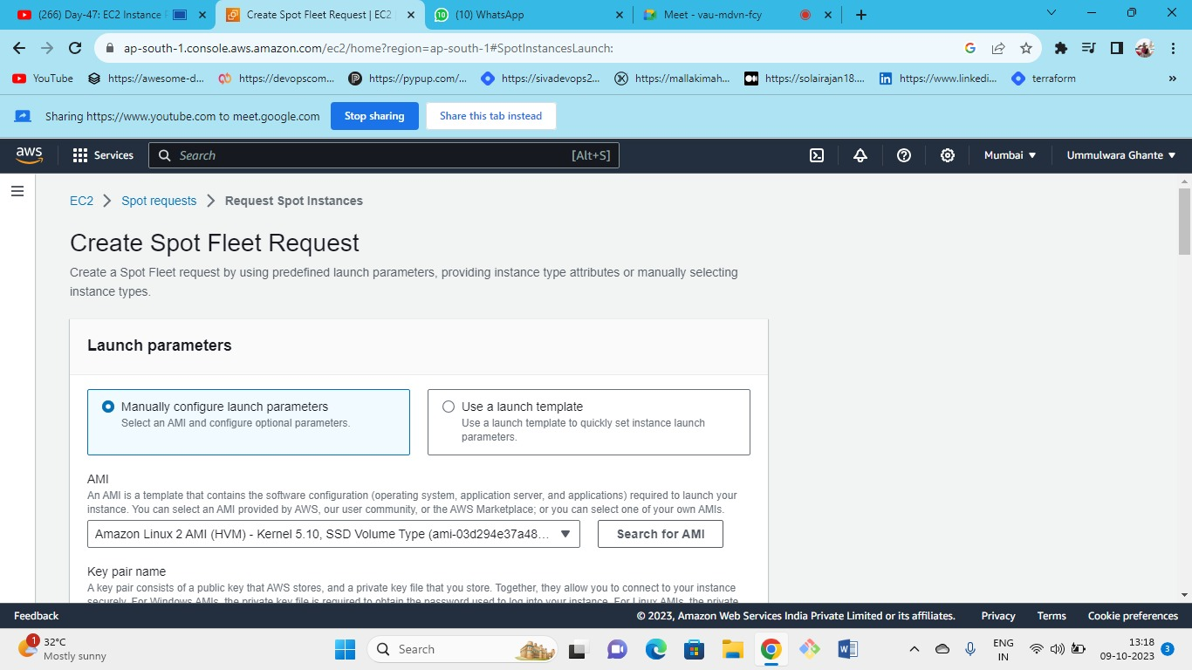



Firstly, we need to create spot fleet request

Select manually configure instance parameters and default Linux AMI

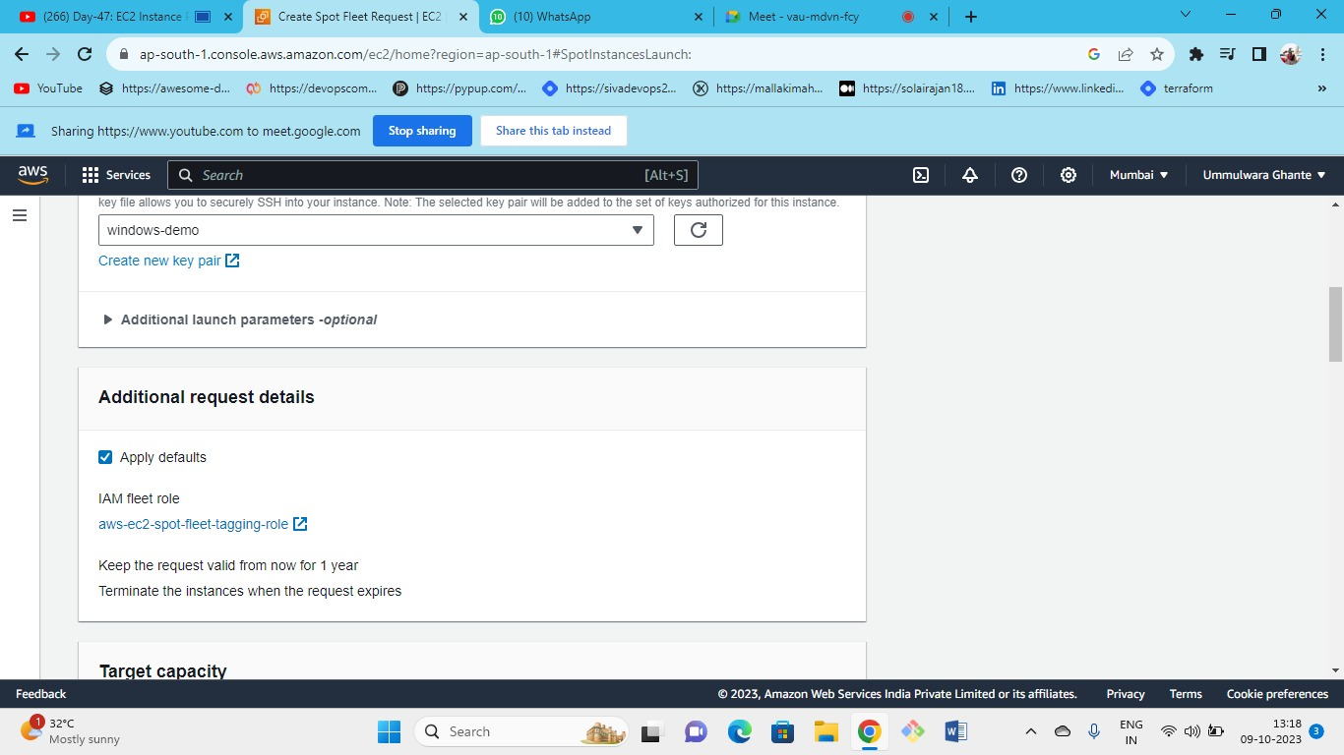



Select the Key pair and rest as default

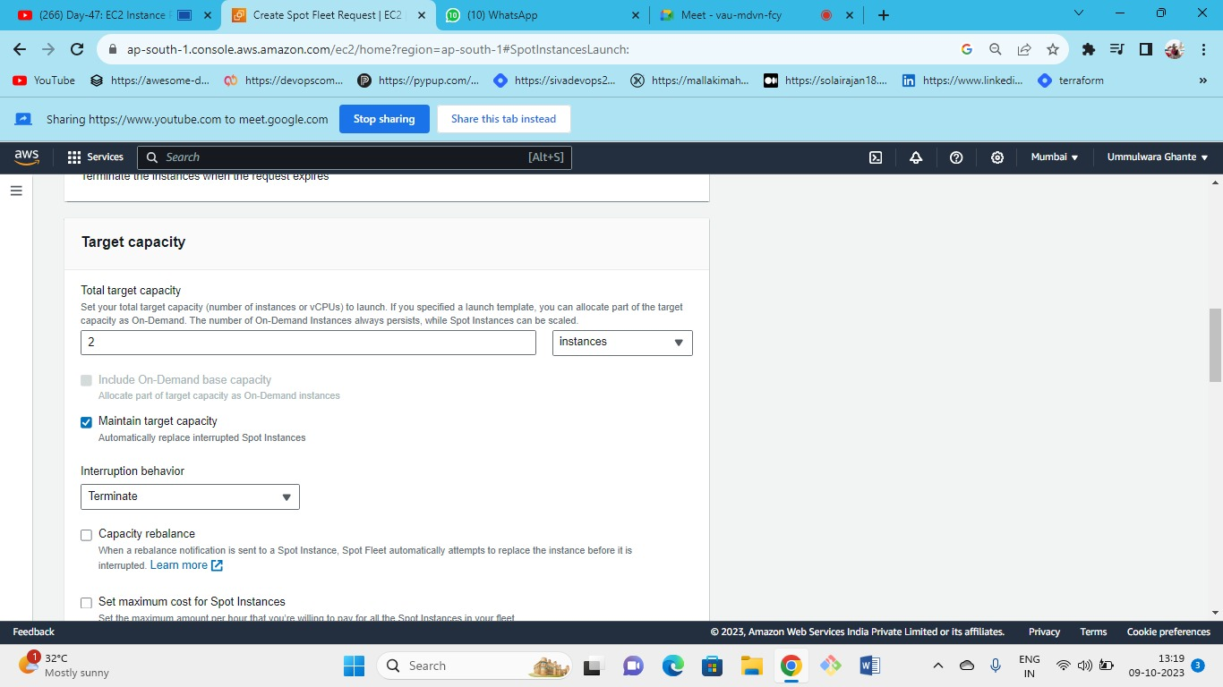



* Tick on maintain target capacity so that if instances are interrupted, they get replaced.
* Choose the no of instances that you want to maintain in the target capacity and interruption behavior as terminate.

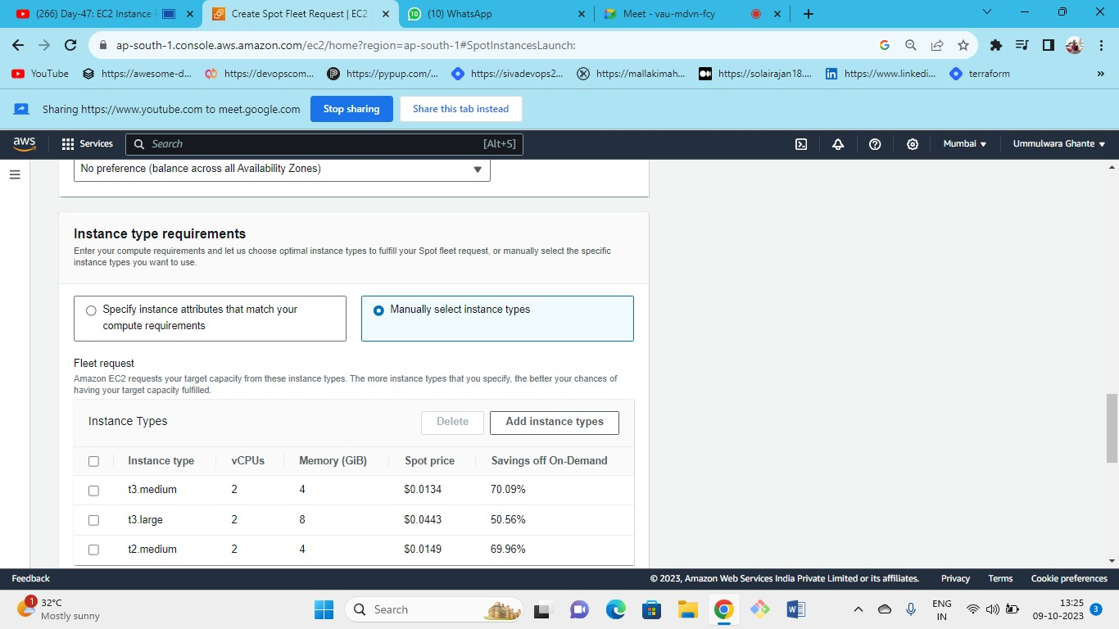



Choose manually select instance types and select types of instances that you want.

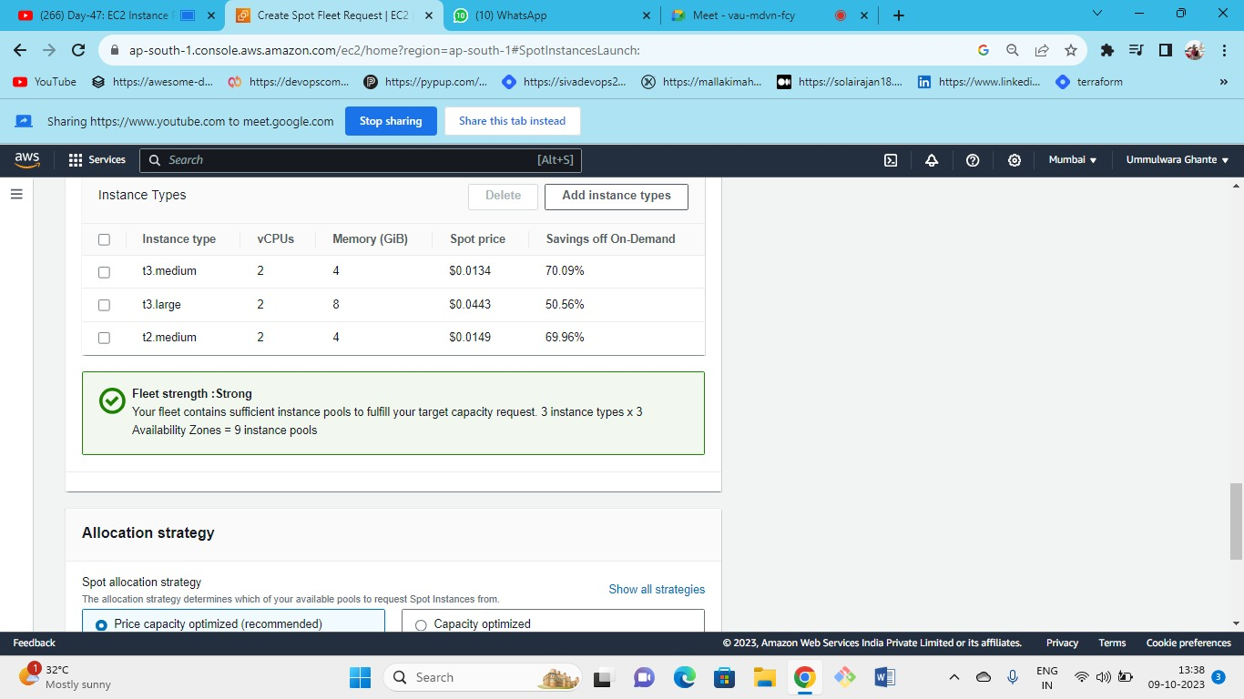



3 types of instances are deployed in 3 AZ so total we get 9 instance pools.

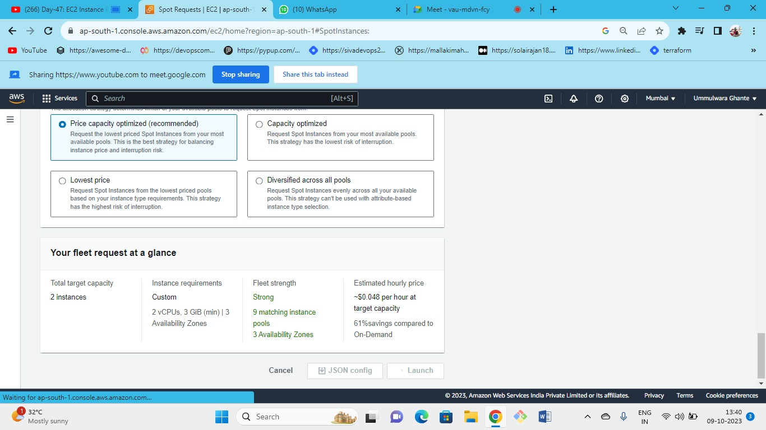



Summary of all the selection.

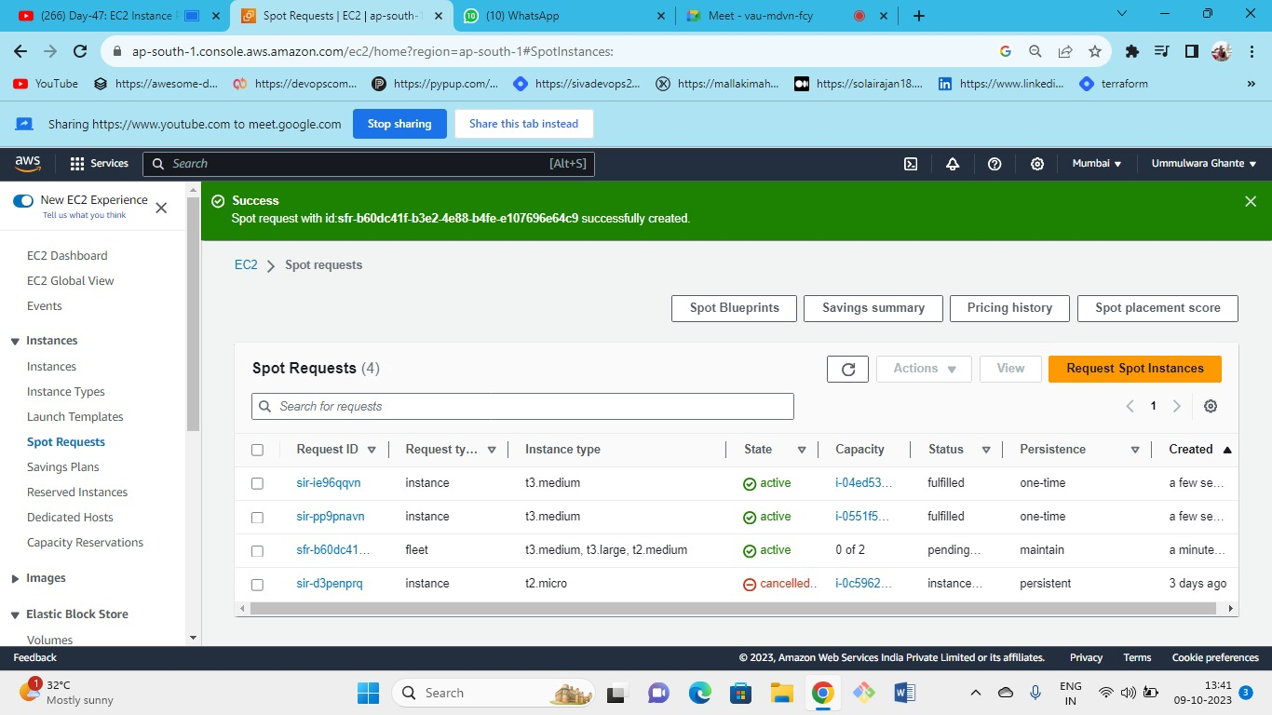



Spot fleet launched successfully

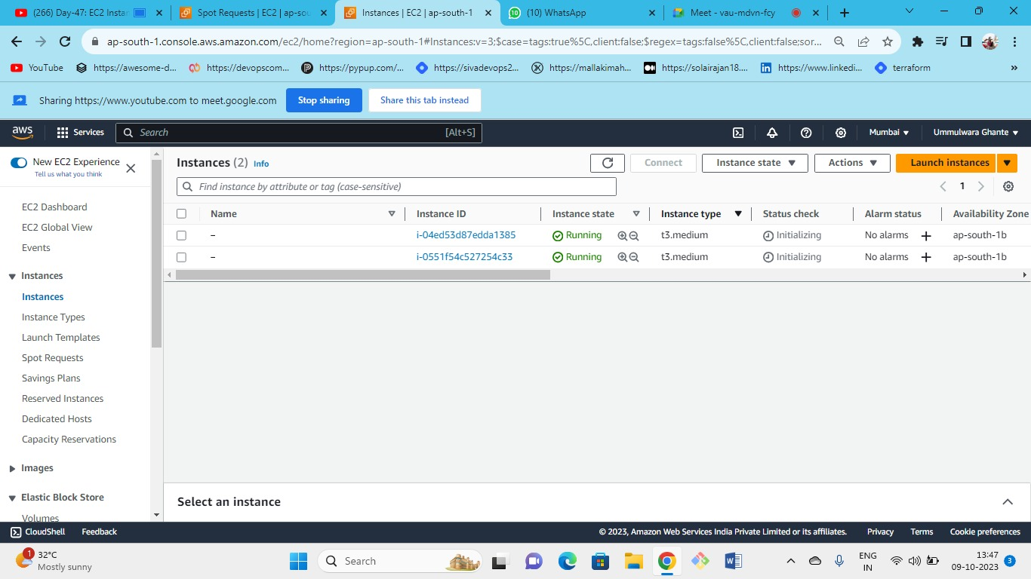



Following are the 2 instances launched of t3 medium AWS will give you instances depending on its availability in the pool

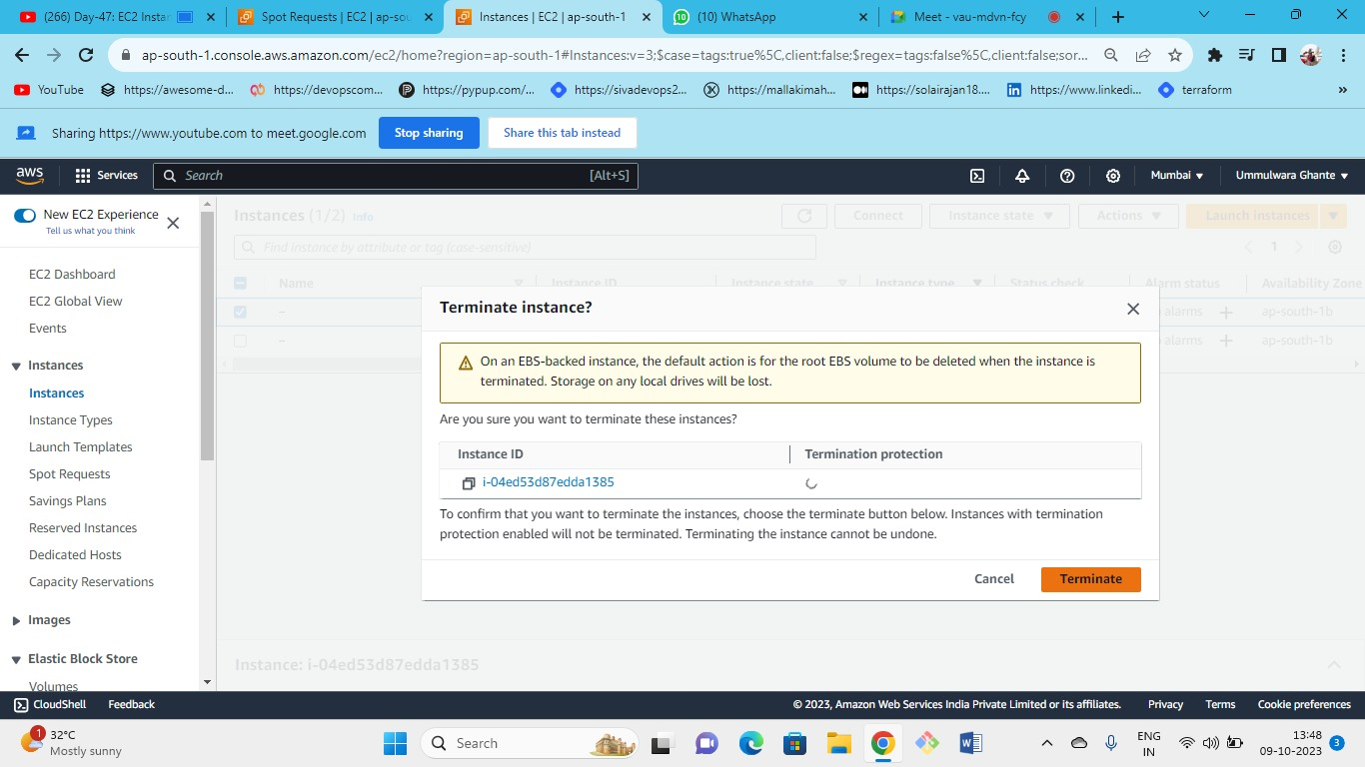



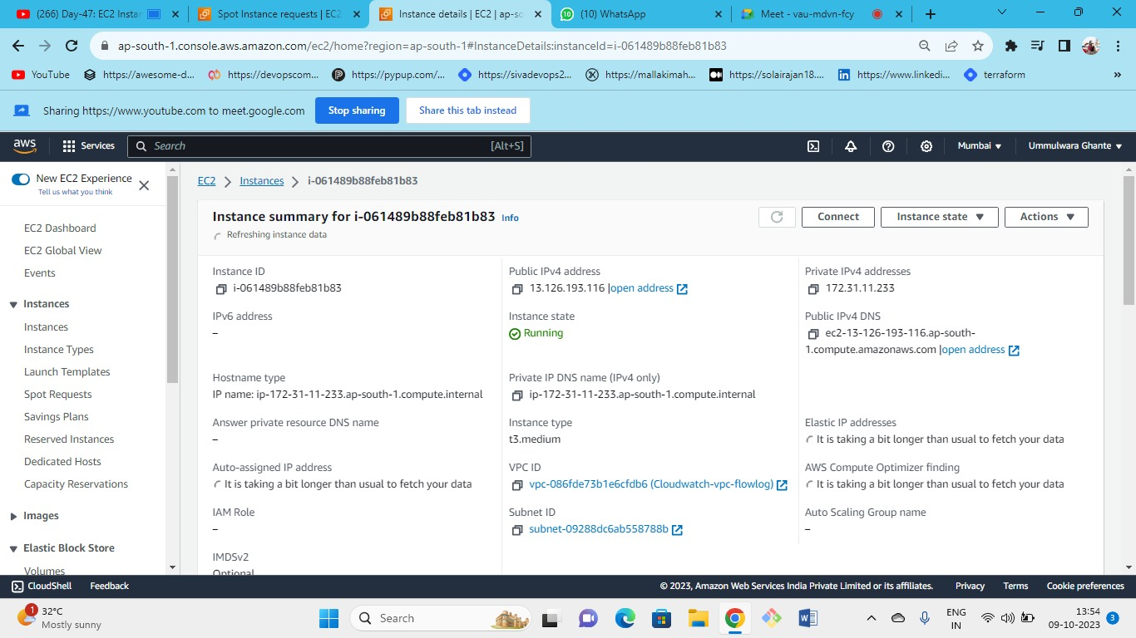



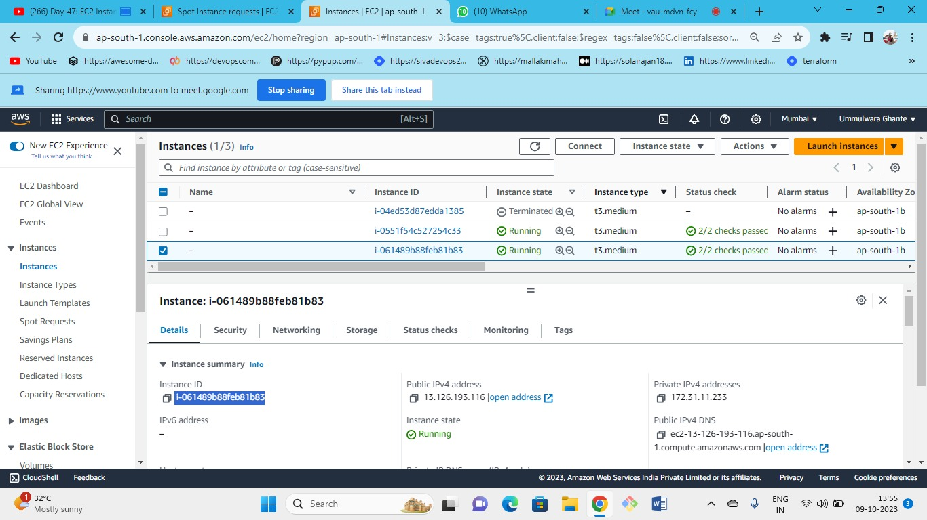



* Every instance has a unique id (i.e., instance id)
* if we need to connect over the internet then use public IP
* private IP is not used outside the private network.

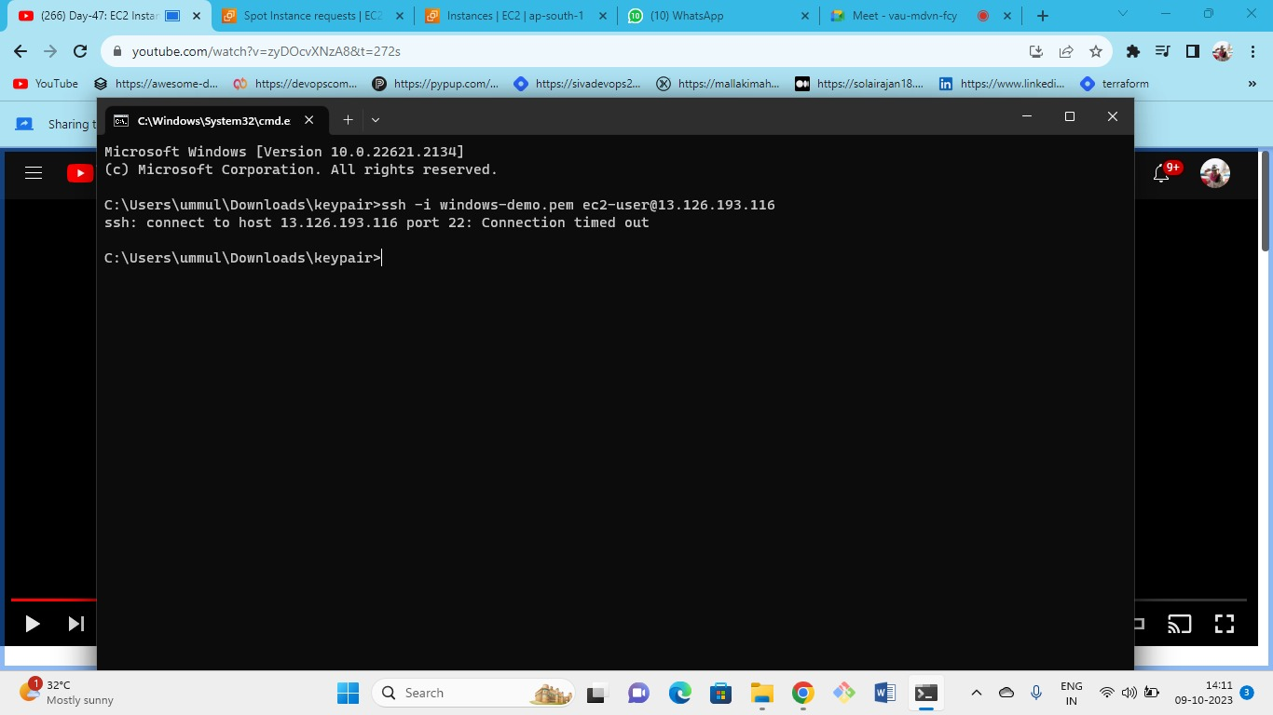

let’s connect to the server by public IP but its showing **time out** then you need to ***open for Port 22*** and ***source as my IP***

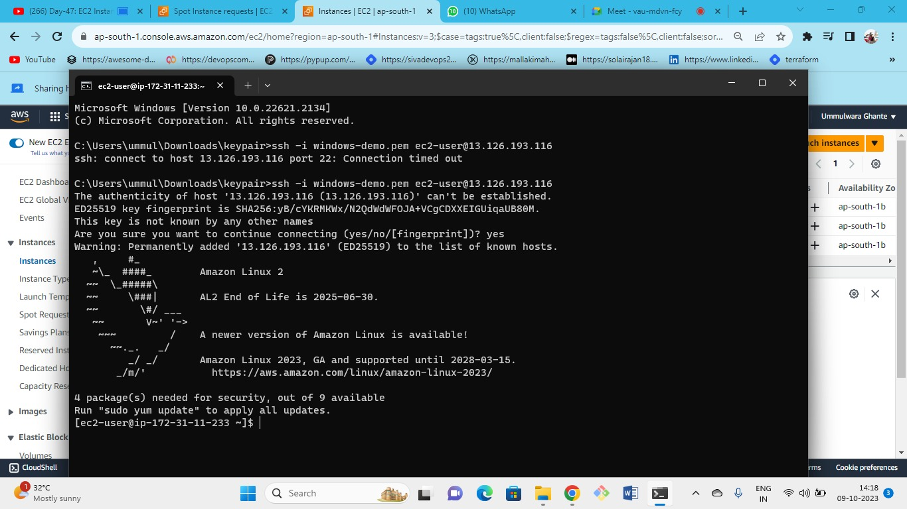



By public IP

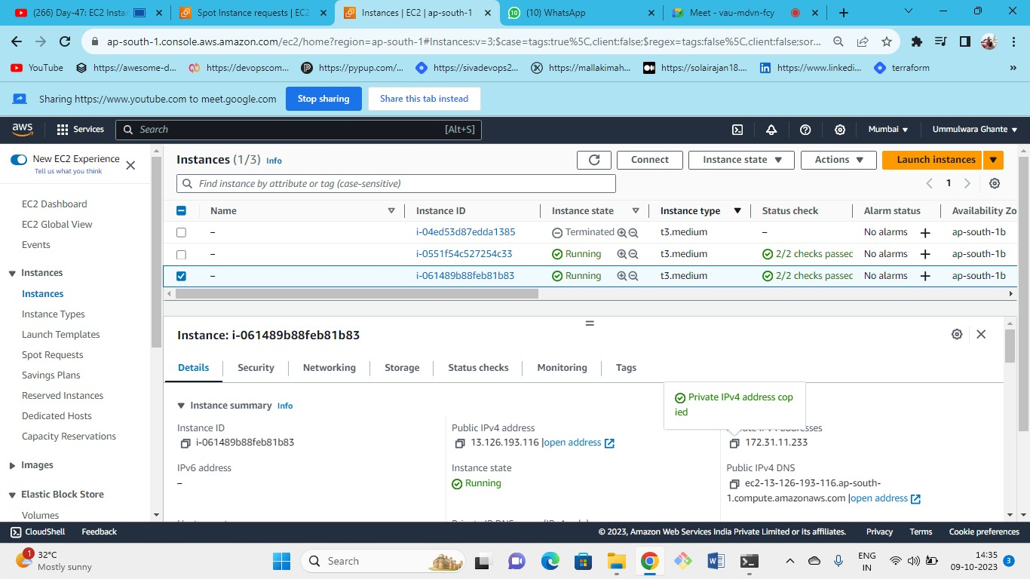



now copy the private IP

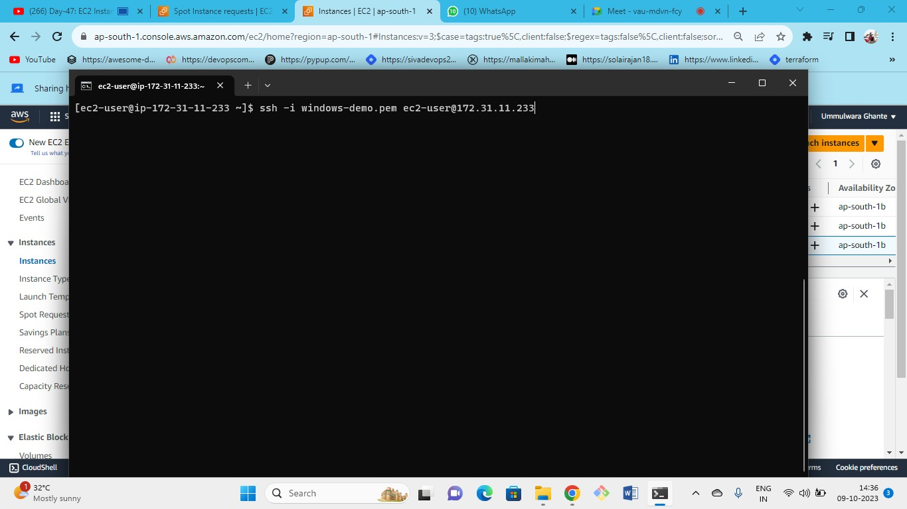

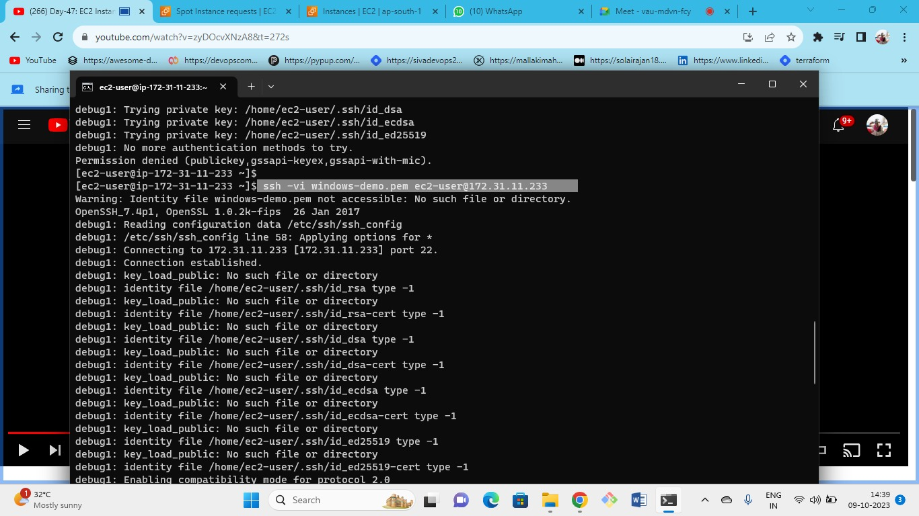

Private key can only decrypt the data because the part of the key will be only with you then you are encrypting your private key to aws ec2 server

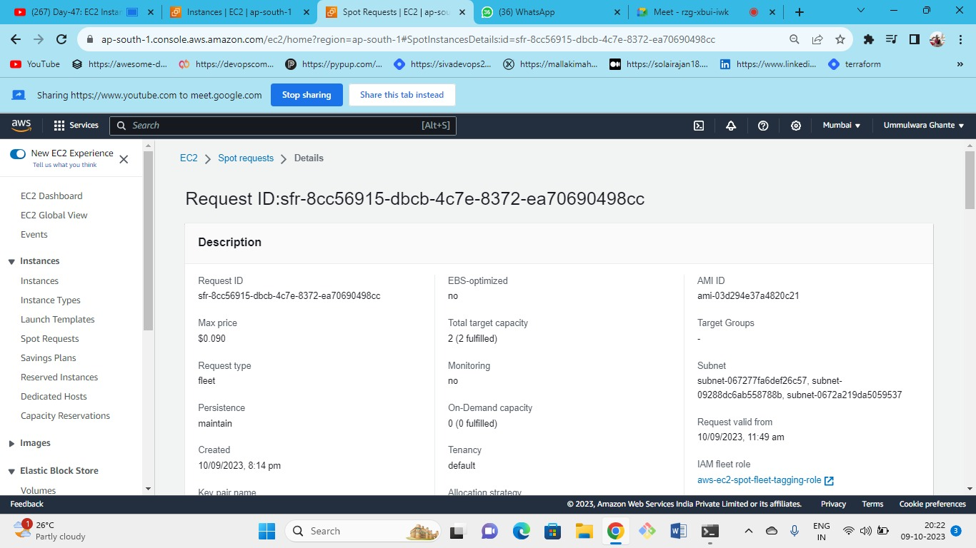



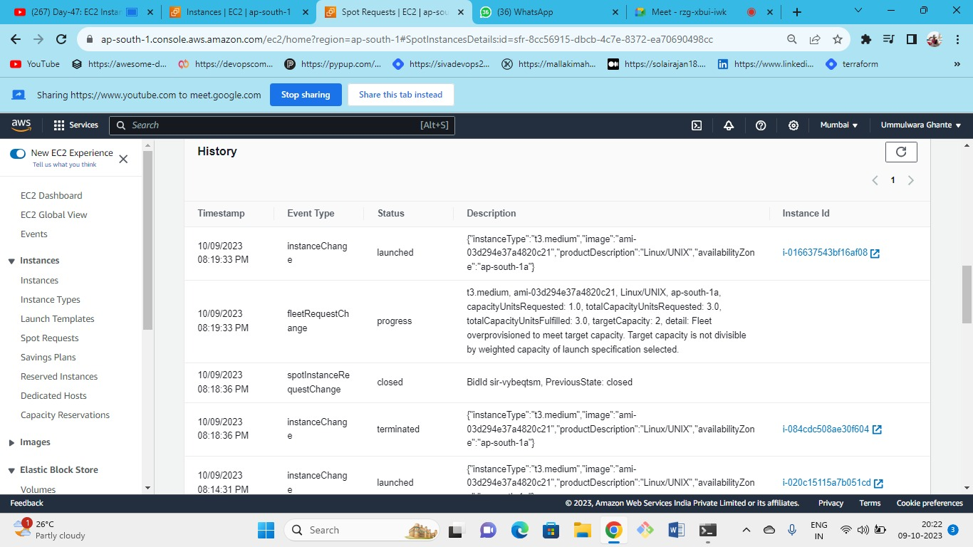



You can also watch the history and the records of the events created by spot instance fleet

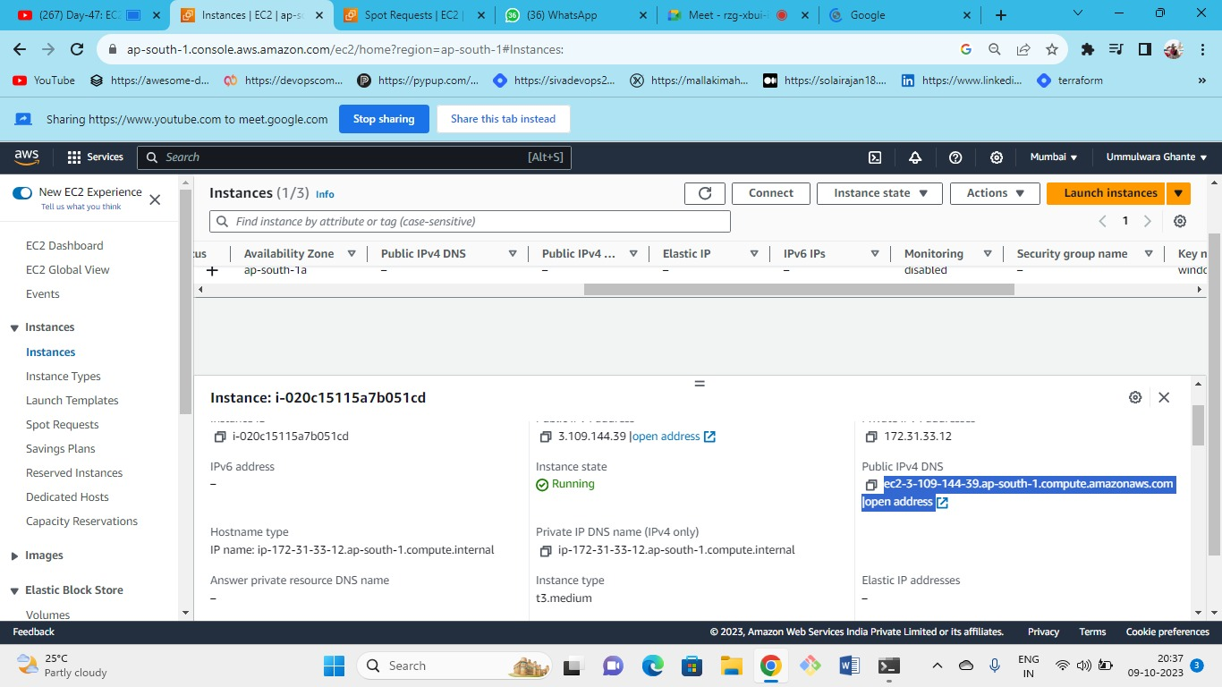



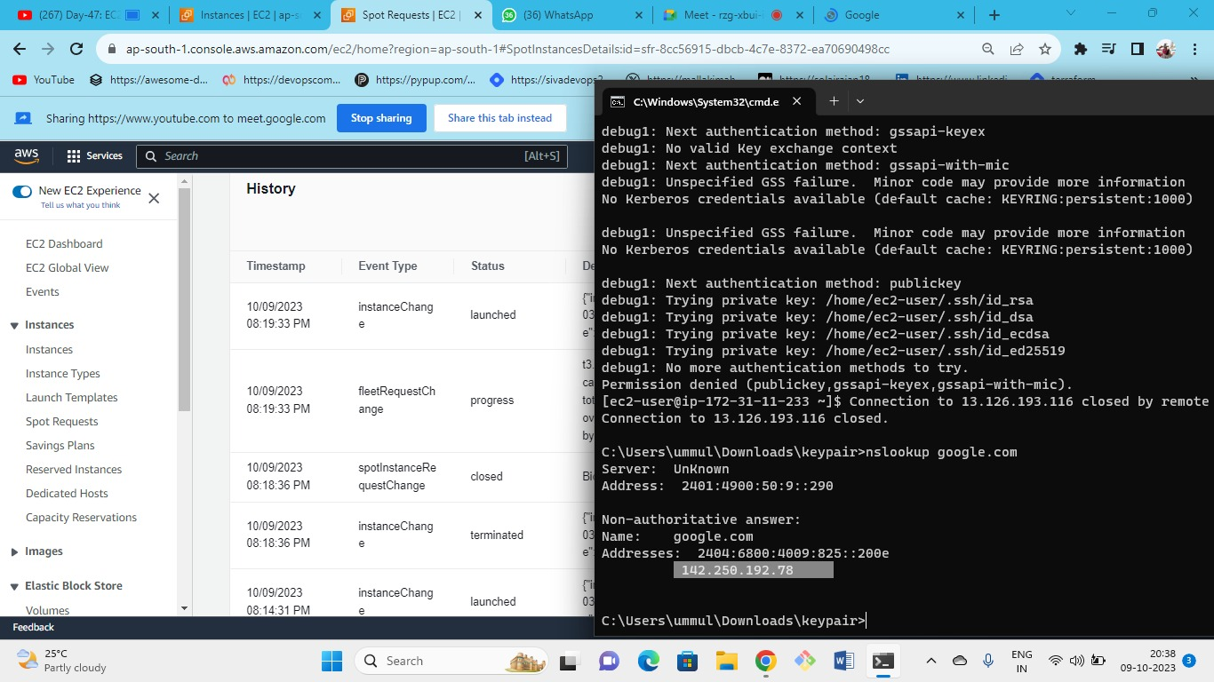



As we getting some IP of google.com

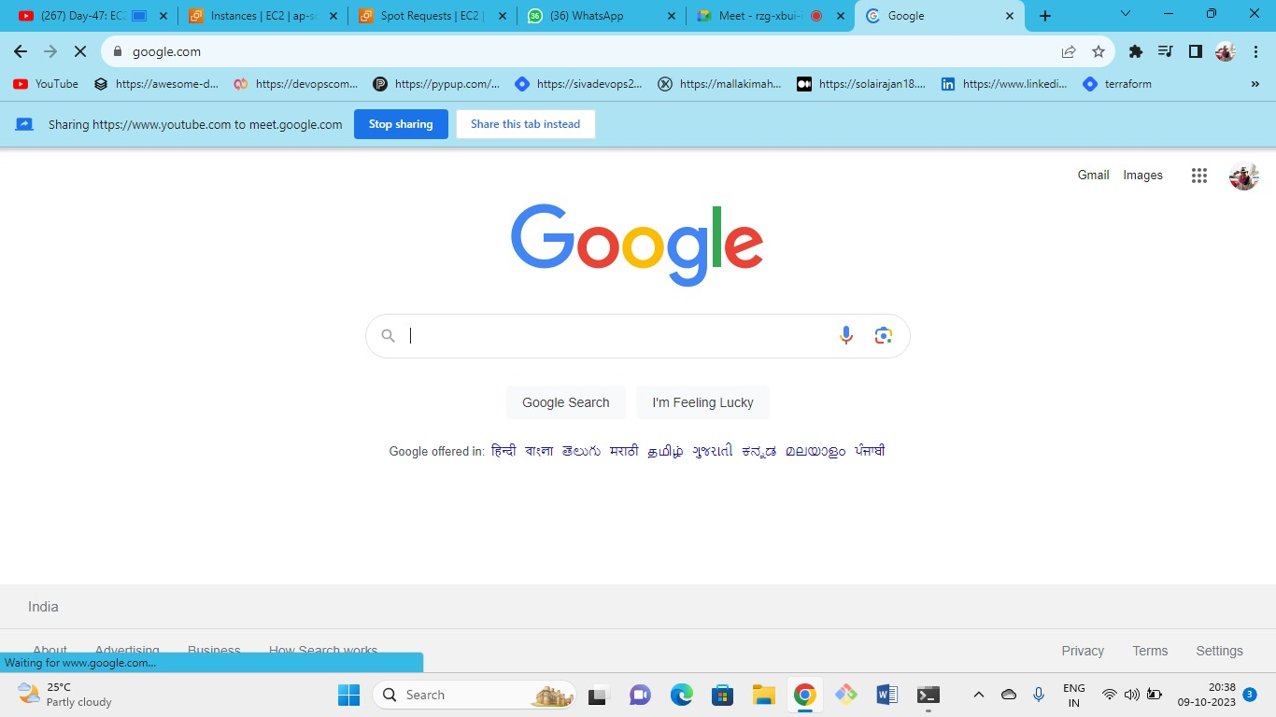

* Getting IP from google.com is called as domain name
* And the IP behind this domain are backend server IP’s These IPs changes every time so we can’t remember the IP so DNS is the easy method to remember the domain names.
* DNS- convert domain name into the IP

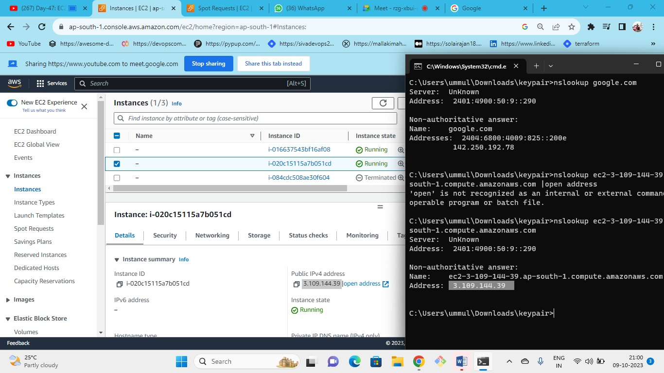



As we are resolving this DNS, we are getting same IP

This domain name(ec2-3-109-144-39.ap-south-1.compute.amazonaws.com) is nothing but the name of this IP (that is public IPv4 address)

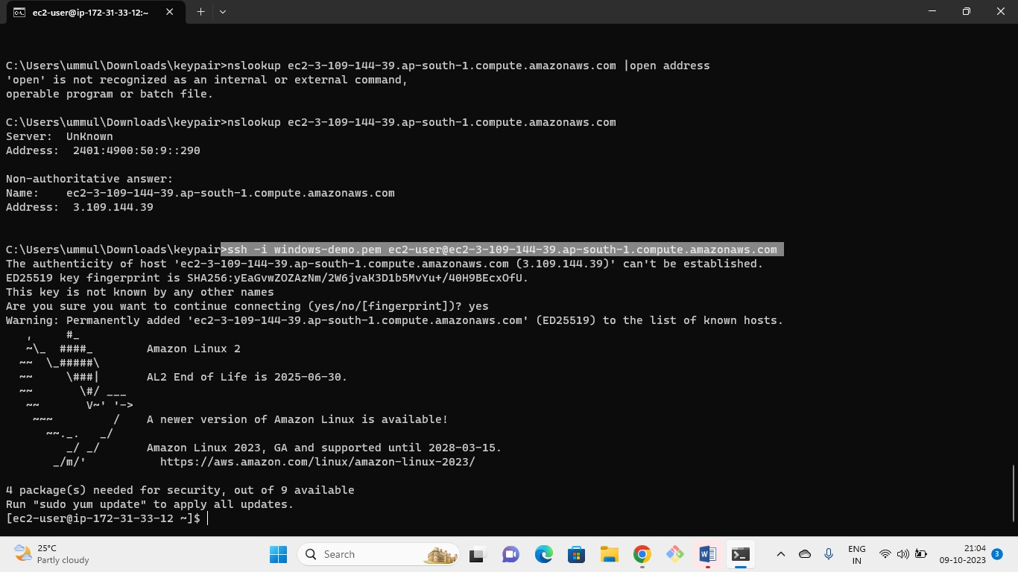



by using DNS name also we can connect to server

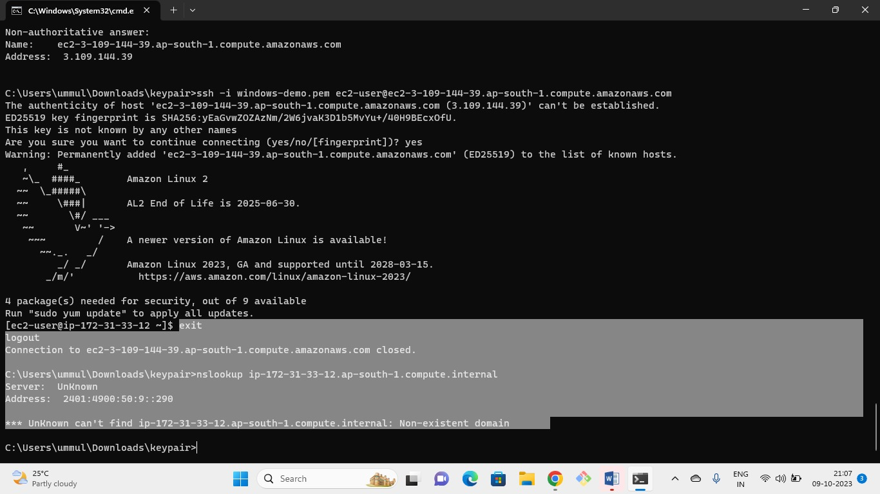



As we are out of the server, we cannot resolve this.

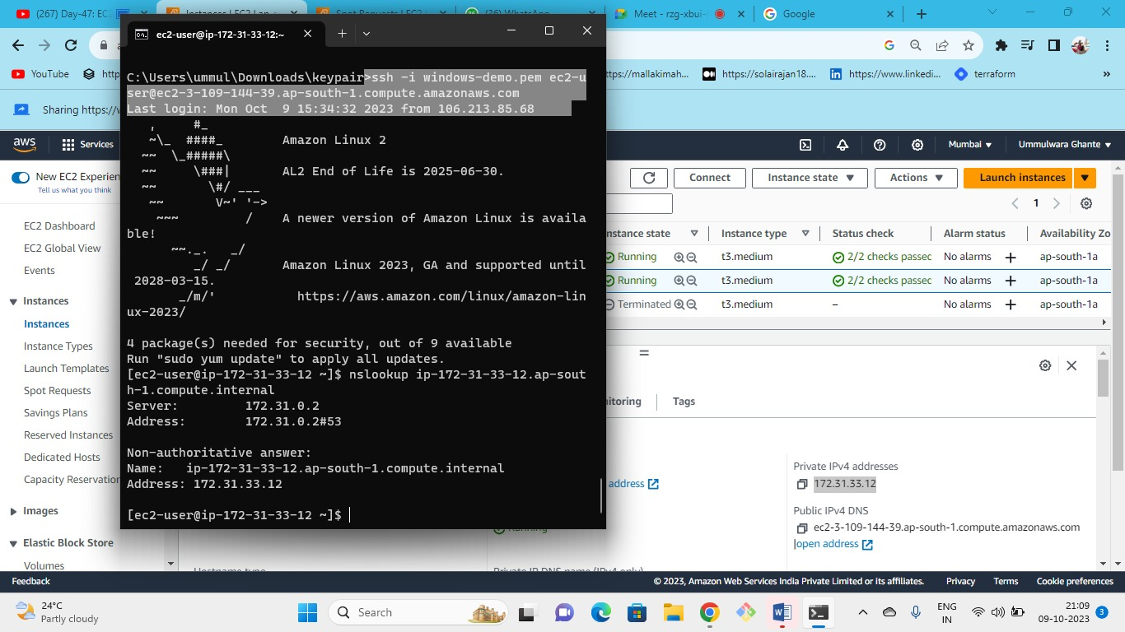



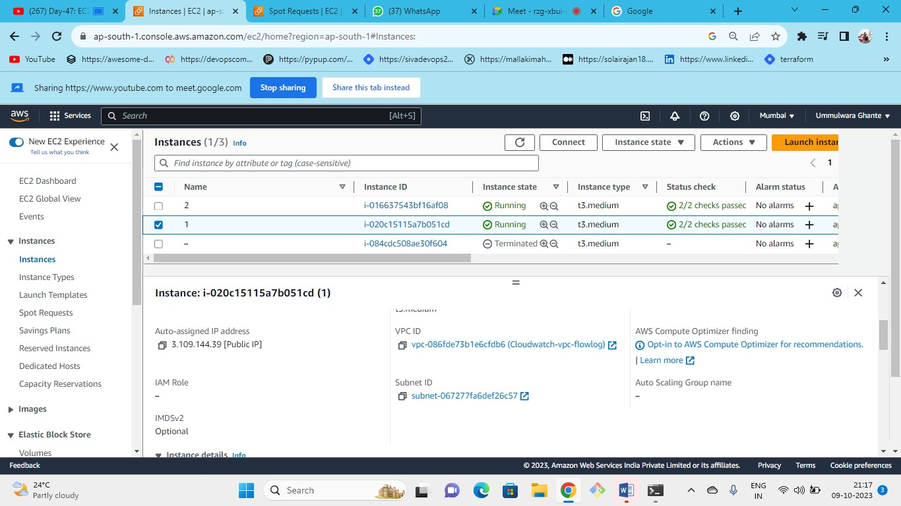



In this VPC and subnet instance is launch.

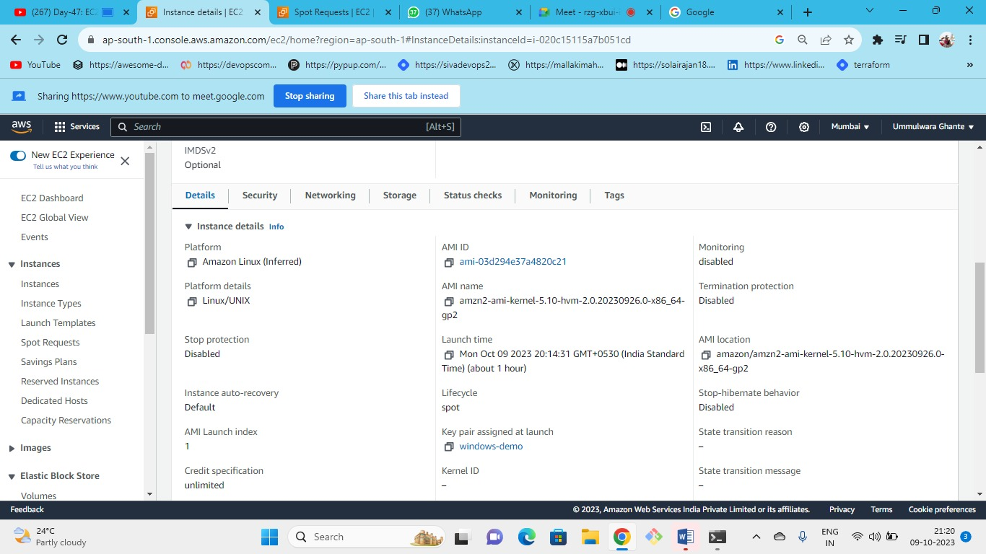



Ami Is an image that I used while launching the ec2 instance and it is a unique ID

**Security page**

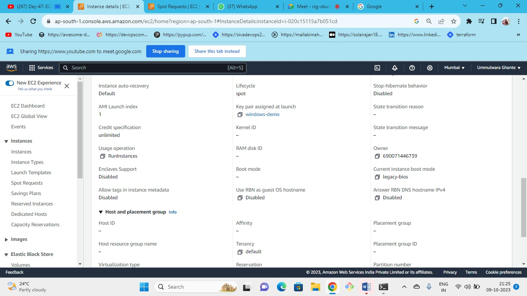



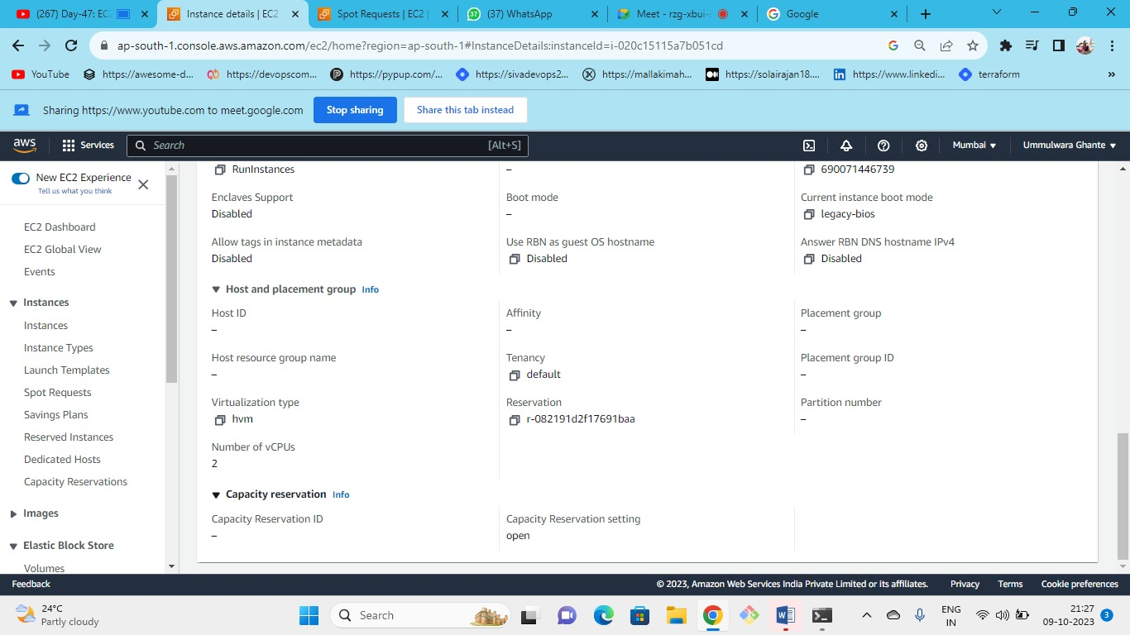



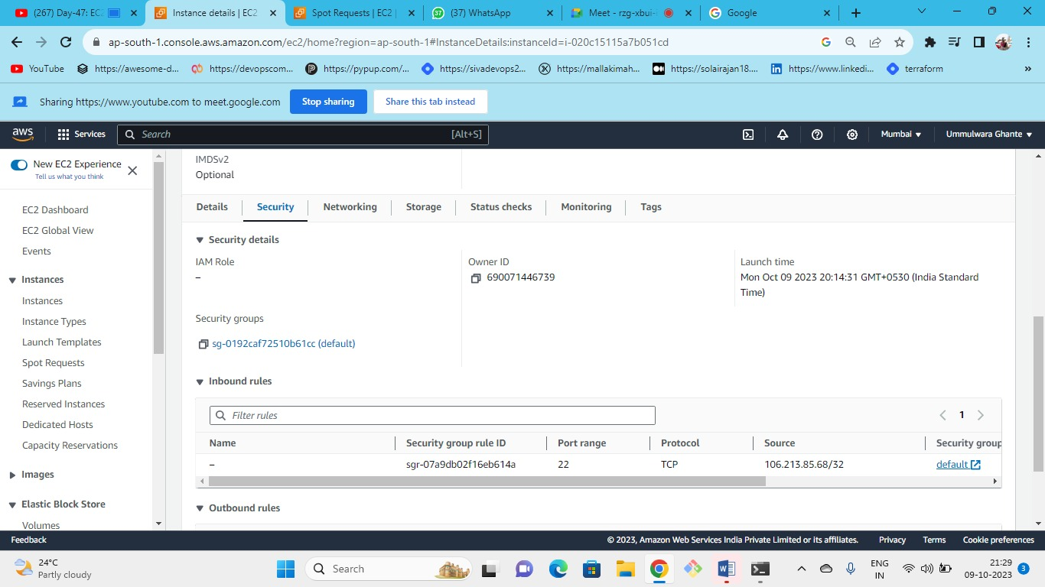



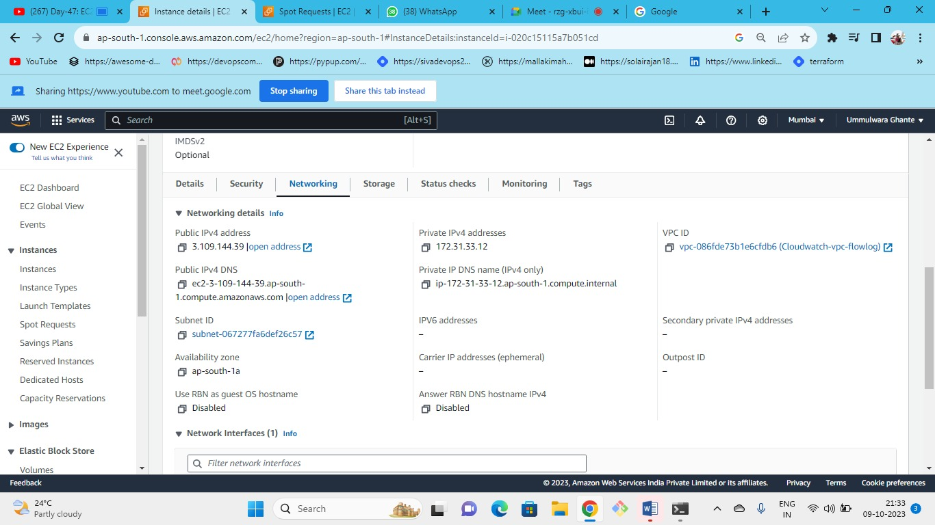



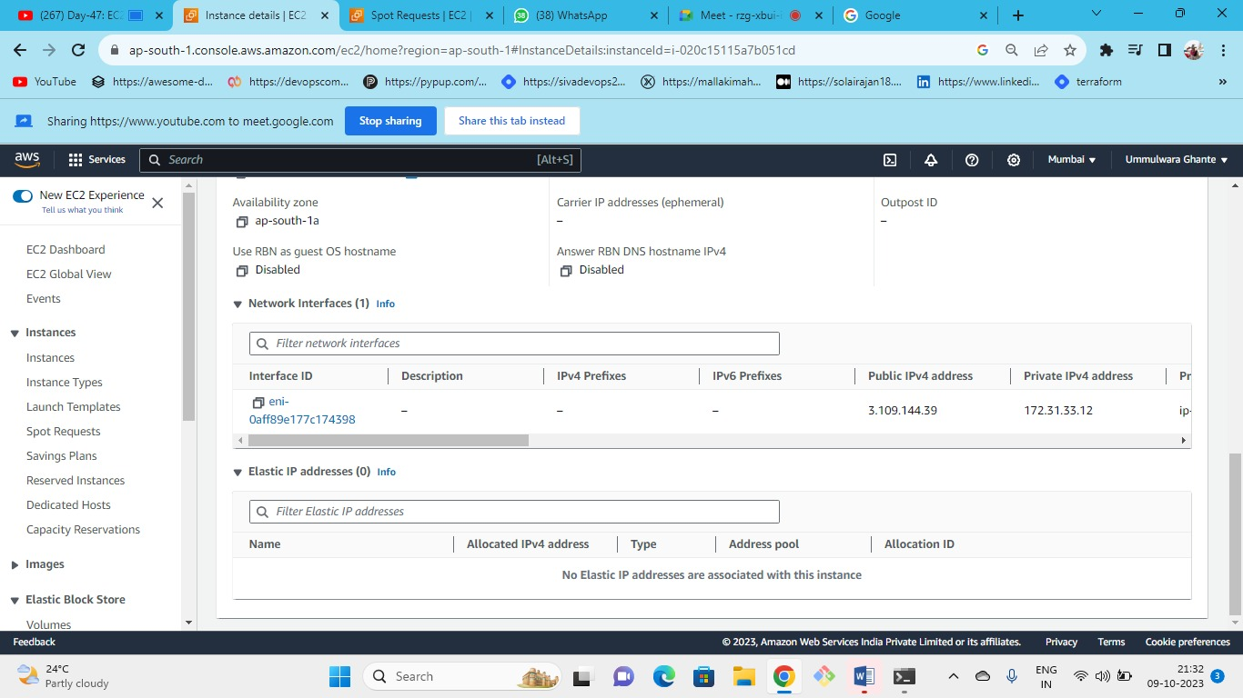



* NIC is always attached to a server
* NIC card communicate over the internet, private network etc.
* Whatever flows outside the server it goes out through NIC card
* This card gives functionality (communicate, create a network, communicate to other computers inside the network(i.e., local network or public network)
* You cannot launch a server without NIC.

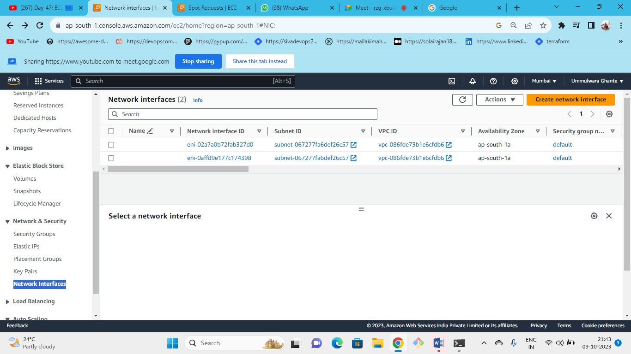



SG is attached in the backend to the network interface not to the server.

Create new NIC named as demo NIC

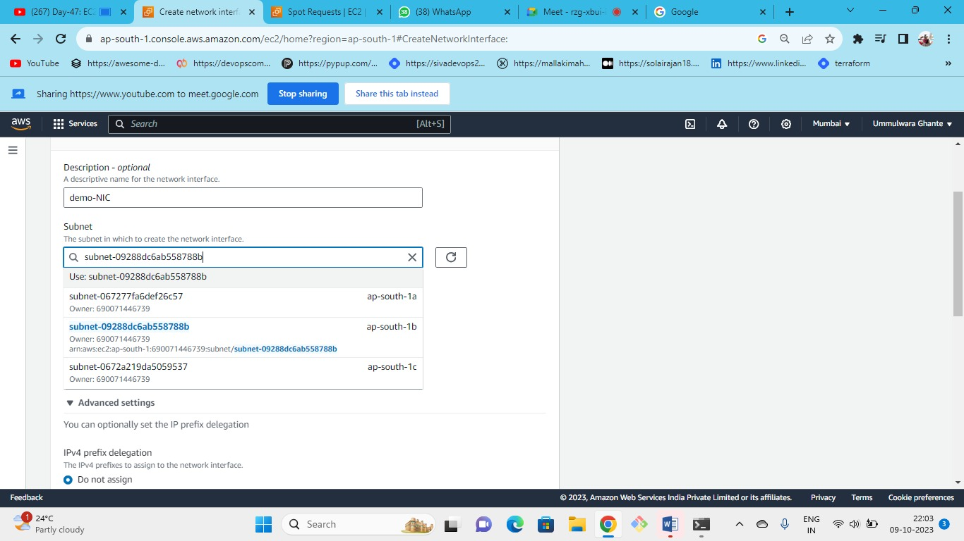



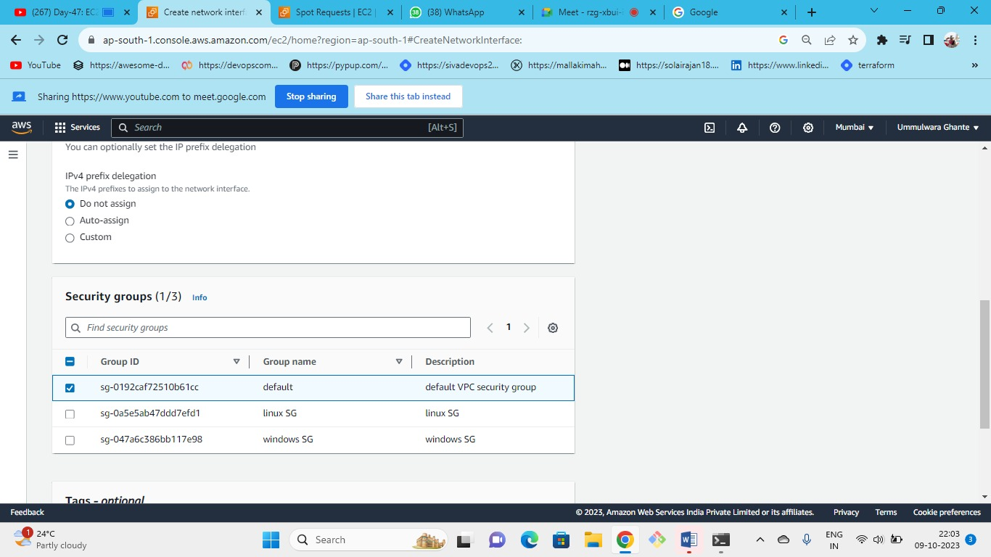



Select the security group that you want to attach to your NIC

Server and NIC should be in the same AZ.

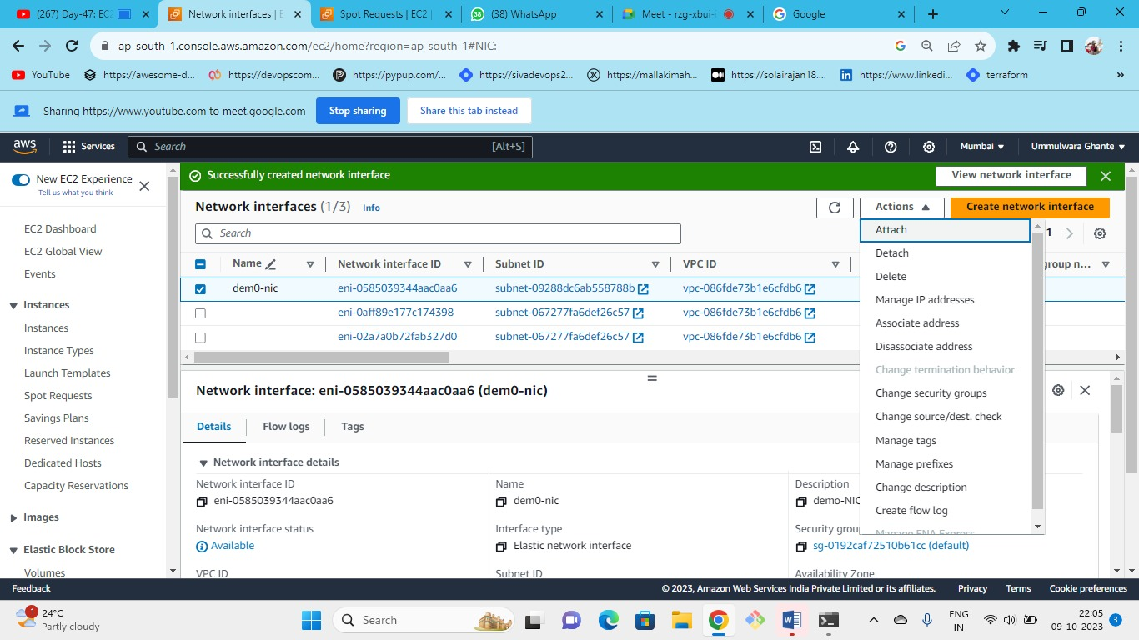



Attach the NIC to the instance

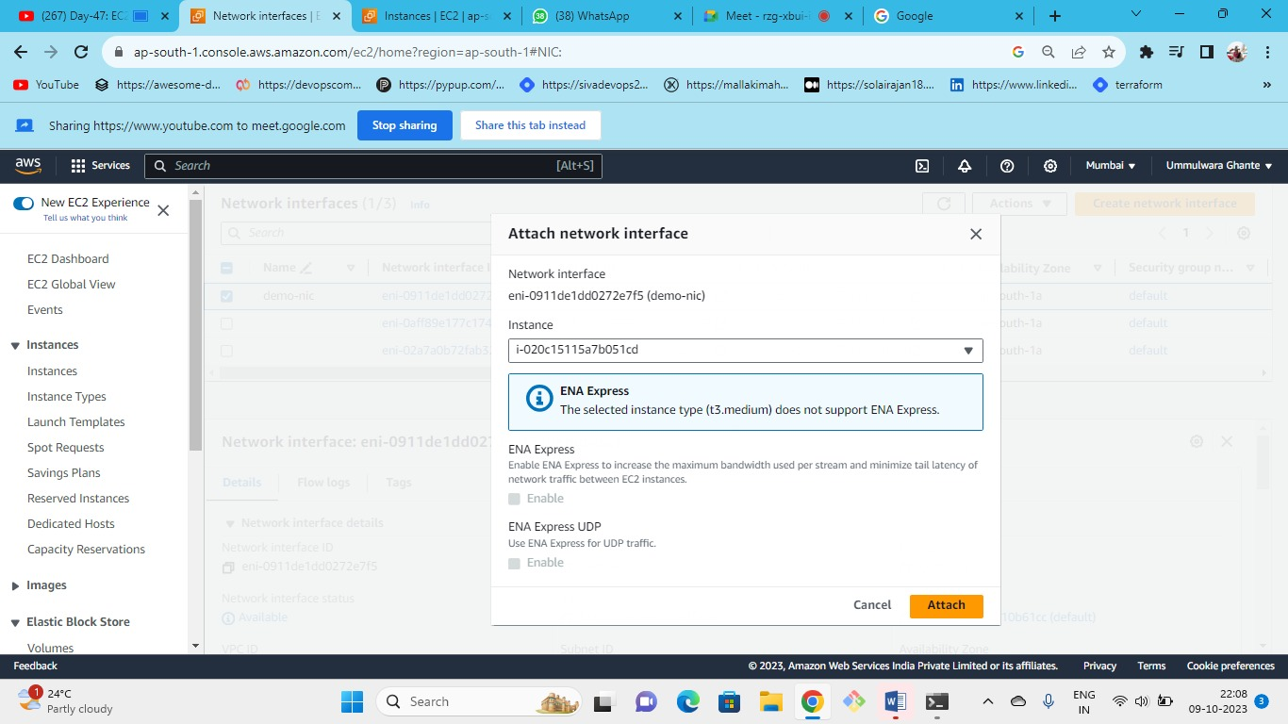



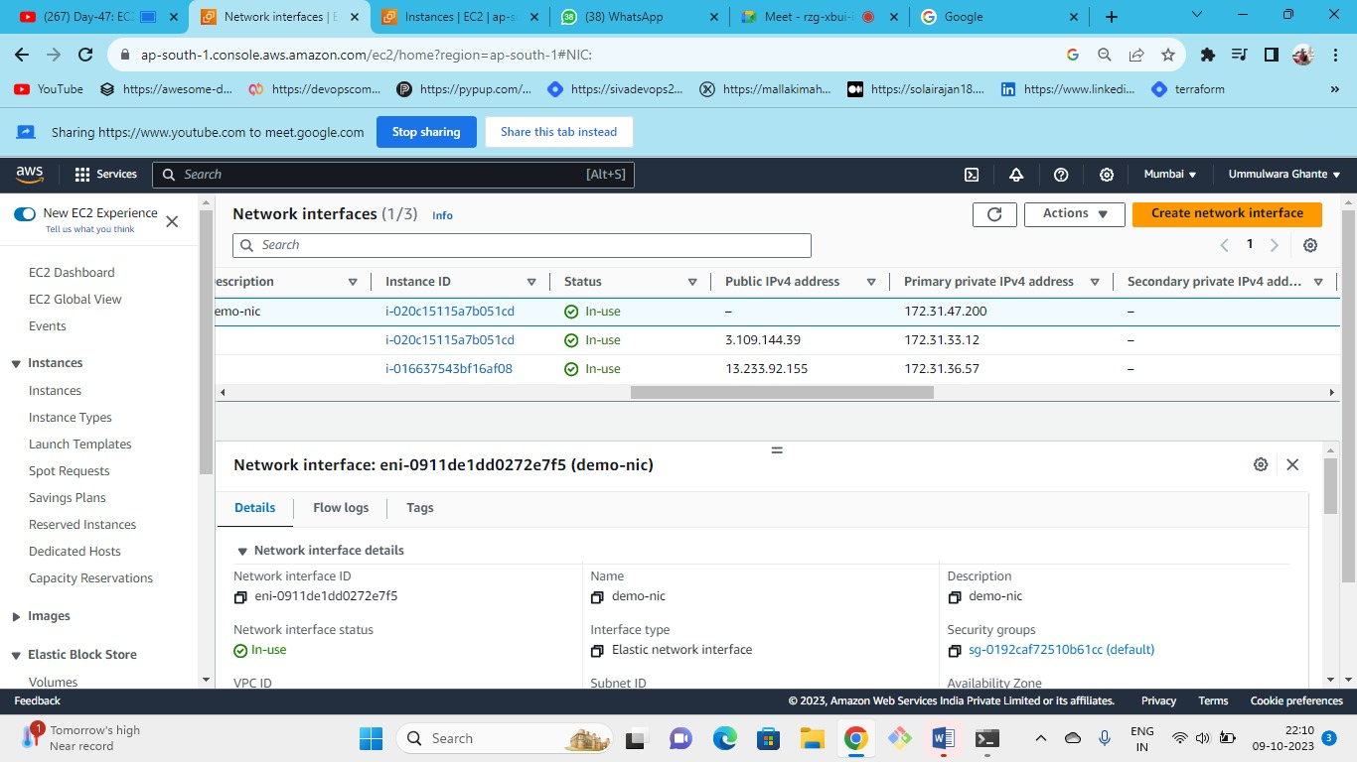



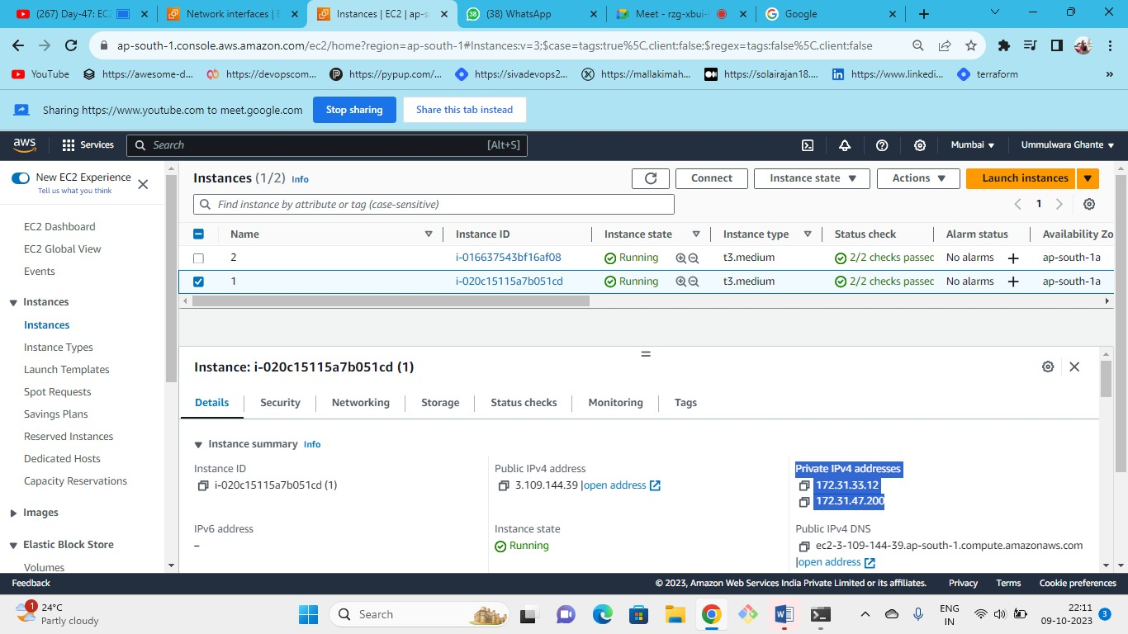



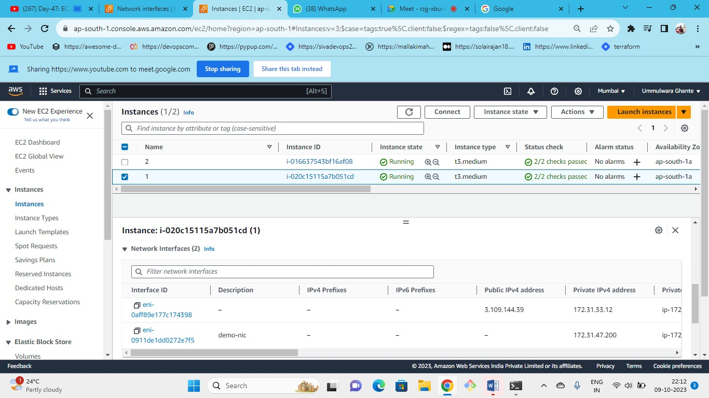



As aws has not provided public IP we can create our own public IP by using elastic IP’s

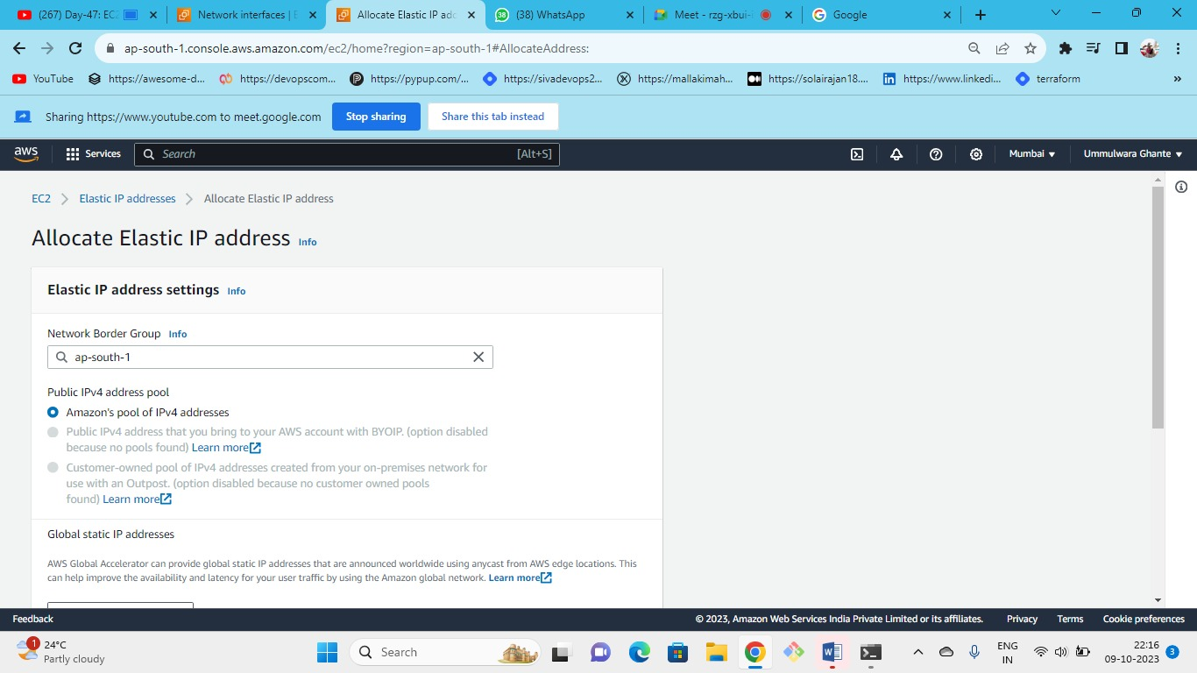



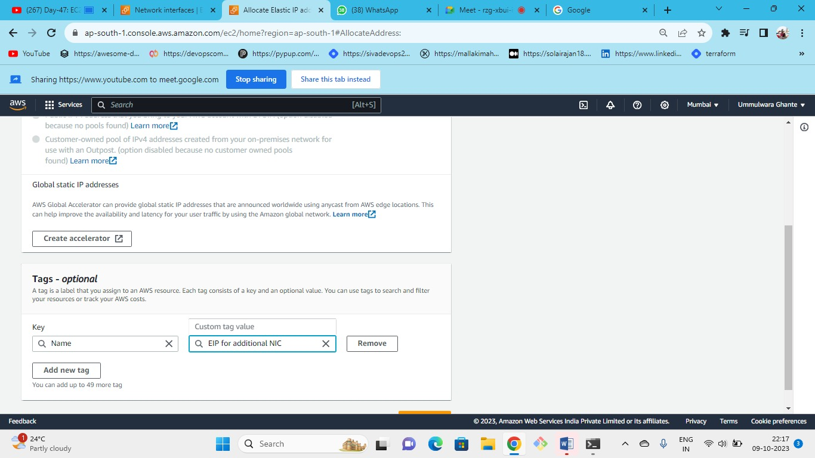



Create elastic IP

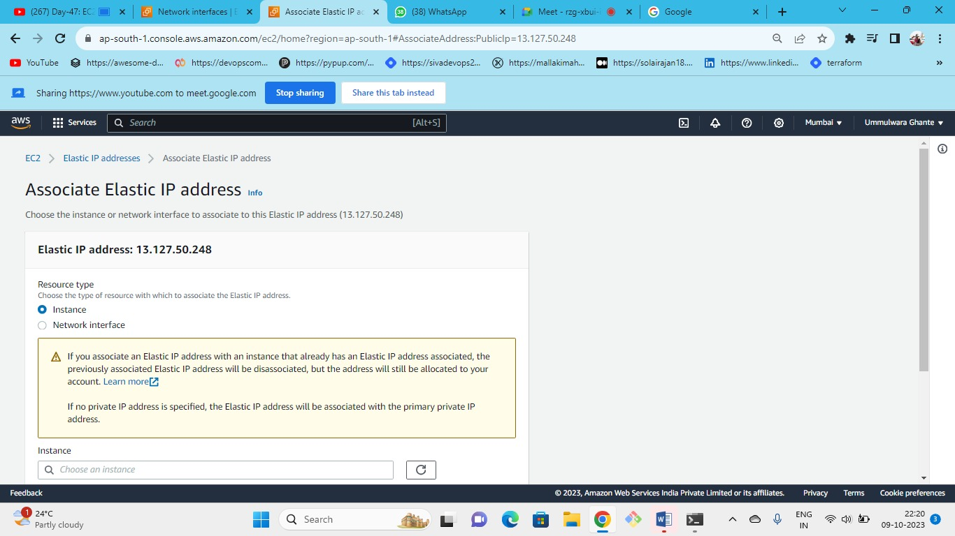



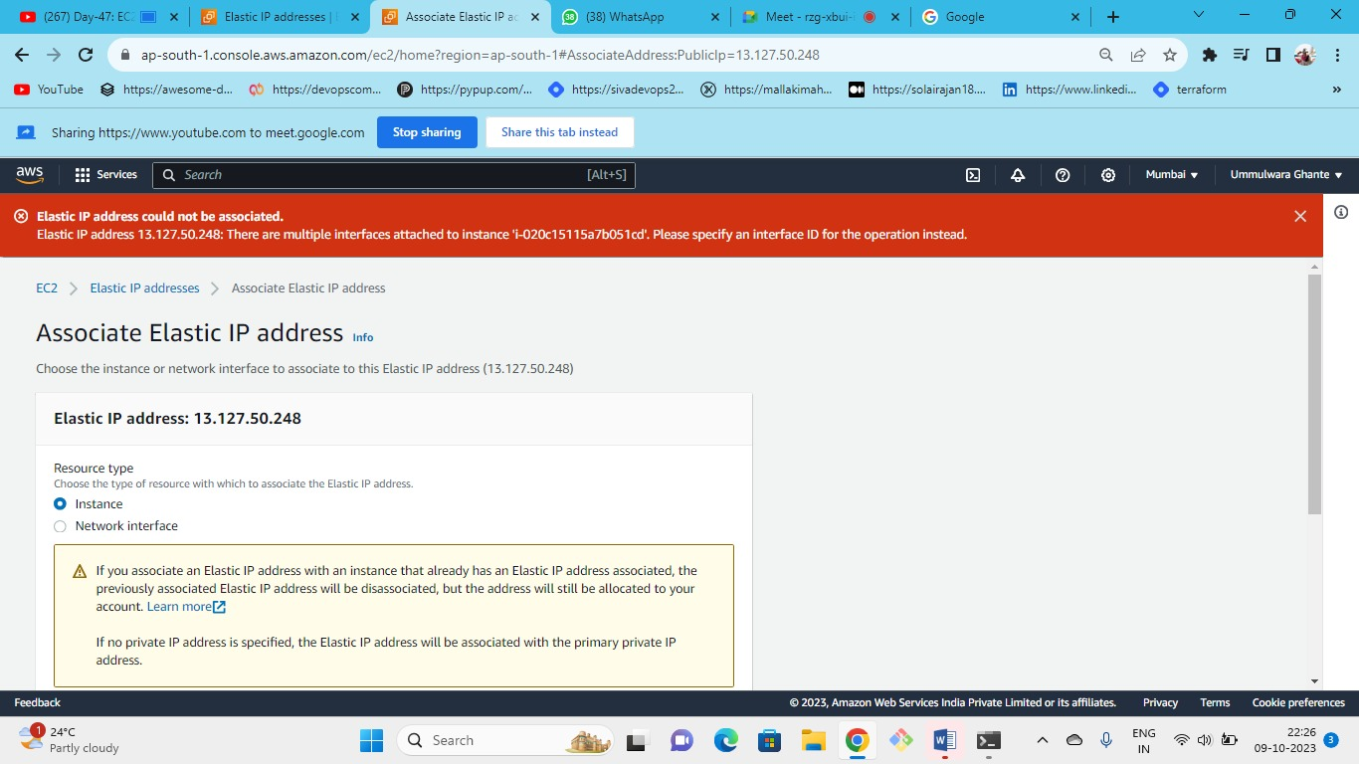

Here to associate EIP we have 2 options we tried to associate EIP to instance it is not possible because we have 2 NIC attached to our instance so we need to choose attach to specific NIC to which we want to attach our EIP

Note – if we have only one NIC to our instance we can directly associate our EIP because it will be applied to the NIC itself

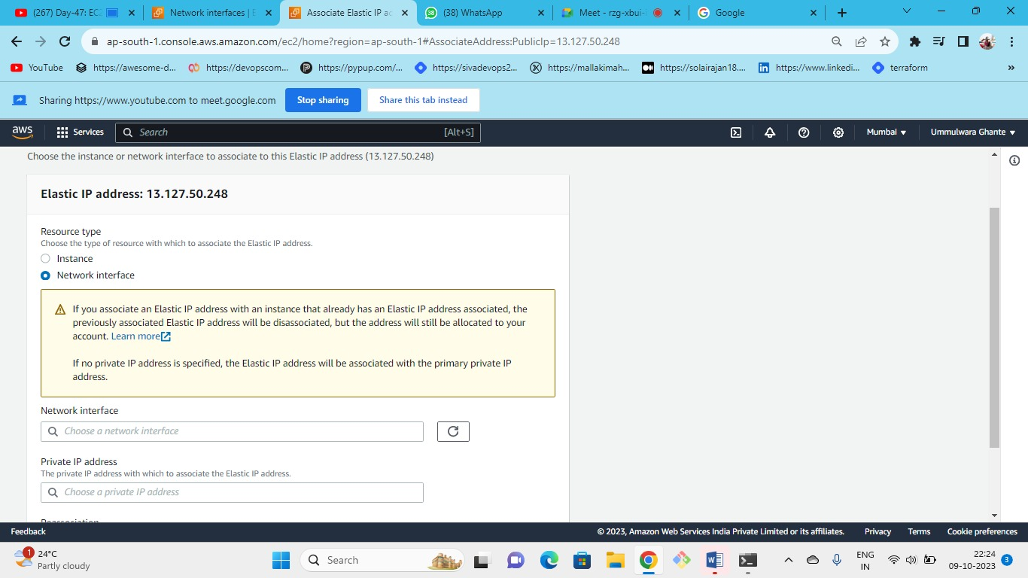



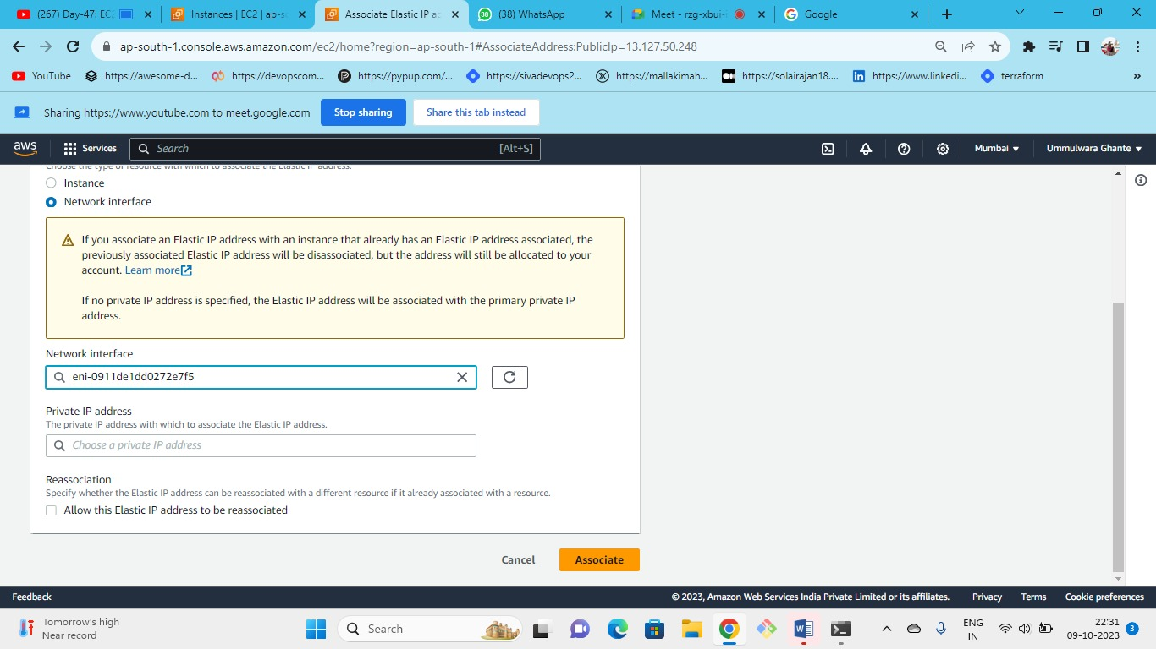



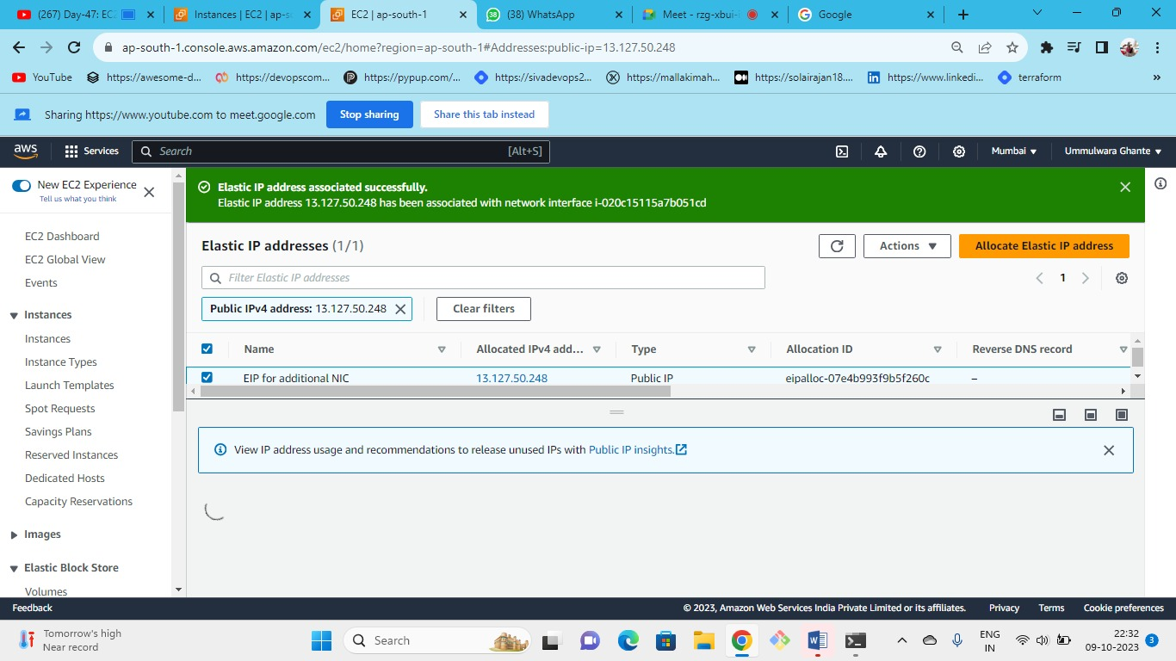



We have successfully added public IP to our newly created NIC

NOTE- We can attach multiple NIC to the instance but the no of NIC depends on the instance type.

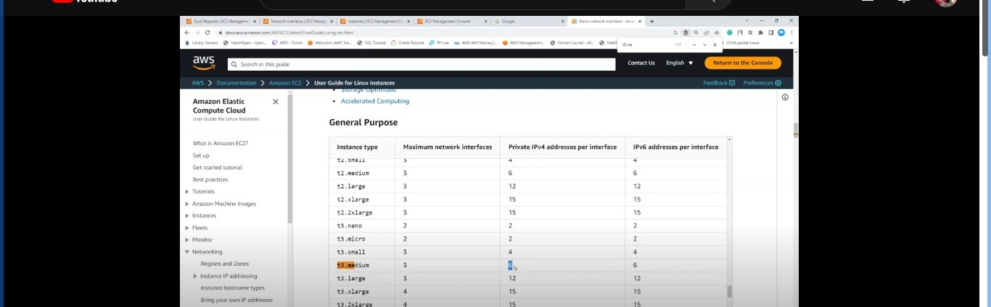



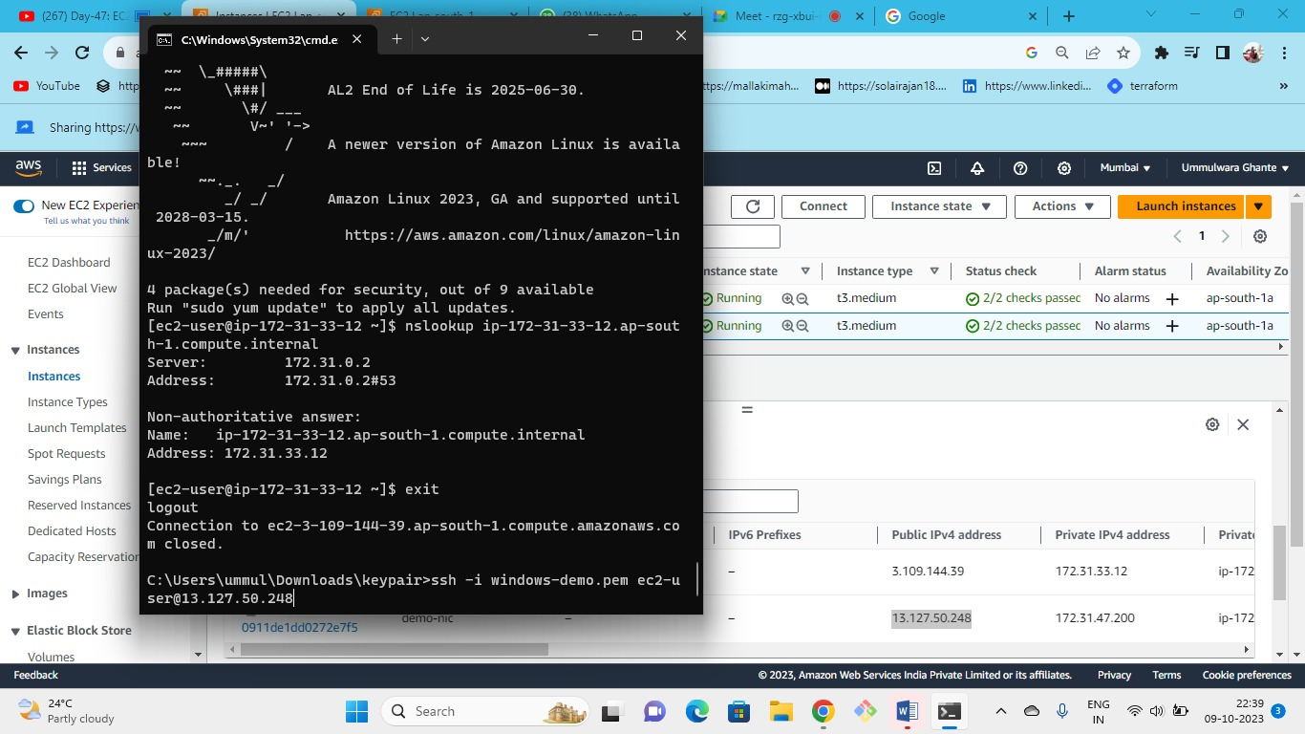



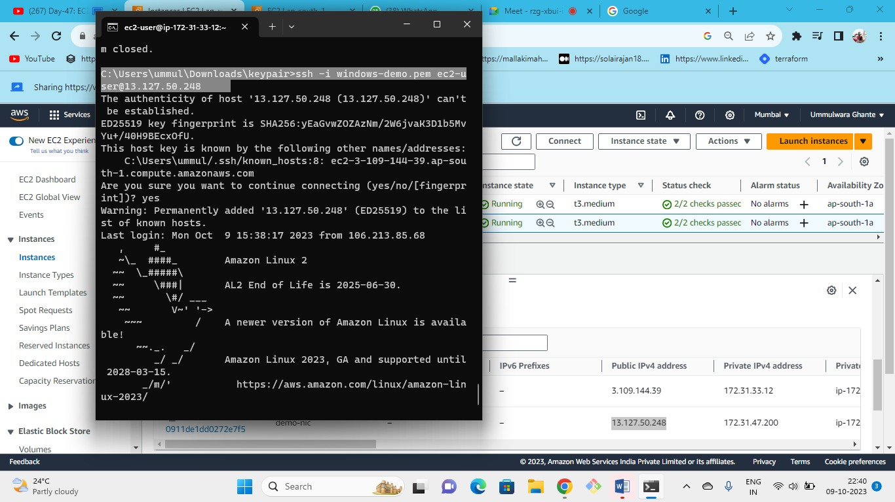



Successfully connected